Lesson Plans
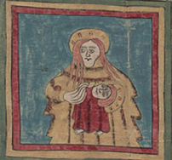
The Huexotzinco Codex http://www.loc.gov/teachers/classroommaterials/lessons/codex/
Students will analyze a set of pictograph documents created by native peoples of Puebla, Mexico in 1531. Students will take on the role of historians, study the documents, and create a scenario to explain what these documents were for, who created them, and why. The codex was an accounting of excess taxation and students will decode the images and tabulate the quantities of goods paid to the local government.
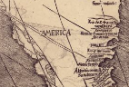
Waldseemüller’s Map: World 1507 http://www.loc.gov/teachers/classroommaterials/lessons/waldseemuller/
The 1507 World Map by Martin Waldseemüller is one of the world’s most important maps. For the first time, this map labels America and shows the continent as a separate land mass. It is often referred to as America’s Birth Certificate. Students will investigate this map by looking closely at the details of each section of the map and then draw conclusions on the revelation of this new and unusual world to the people of 1507.
Primary Source Sets
Each set includes selected primary source materials and a guide for teachers.
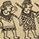
Hispanic Exploration in America http://www.loc.gov/teachers/classroommaterials/primarysourcesets/hispanic-exploration/
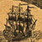
Maps from the World Digital Library http://www.loc.gov/teachers/classroommaterials/primarysourcesets/wdl/

Mexican American Migrations and Communities - 19th and 20th Centuries http://www.loc.gov/teachers/classroommaterials/primarysourcesets/mexican-americans/
Online Exhibitions
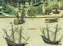
1492: An Ongoing Voyage http://www.loc.gov/exhibits/1492/
This exhibition describes pre- and post-contact America and the Mediterranean world in the same period. Compelling questions are raised, such as: Who lived in the Americas before 1492? Who followed in the wake of Columbus? What was the effect of 1492 for Americans throughout the Western Hemisphere? This exhibition addresses these questions, as well as other related themes, including fifteenth century European navigation, the myths and facts surrounding the figure of Columbus, and the differences and similarities between European and American world views at the time of contact.
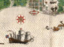
The Cultures and History of the Americas: The Jay I. Kislak Collection at the Library of Congress http://www.loc.gov/exhibits/kislak/index.html
This exhibition explores the pre-Columbian cultures of Central America and the Caribbean as revealed in sculpture, architecture, and language; encounters between Europeans and the indigenous peoples; the growth of European Florida; and piracy and trade in the American Atlantic.
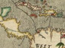
Exploring the Early Americas
http://www.loc.gov/exhibits/exploring-the-early-americas/
Exploring the Early Americas features selections from the more than 3,000 rare maps, documents, paintings, prints, and artifacts that make up the Jay I. Kislak Collection at the Library of Congress. This ongoing exhibition has three major themes: “Pre-Contact America;” “Explorations and Encounters;” and “Aftermath of the Encounter.”
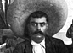
The Mexican Revolution and the United States http://www.loc.gov/exhibits/mexican-revolution-and-the-united-states/ This exhibition tells the dynamic story of the complex and turbulent relationship between Mexico and the United States during the Mexican Revolution, approximately 1910-1920. Includes materials covering the U.S. invasion of Veracruz in 1914 and the 1916 U.S. incursion in search of Pancho Villa led by General John J. Pershing and items depicting the impact of the Mexican Revolution on the United States and the consequences of the Revolution on the future of Mexican politics.
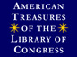
American Treasures of the Library of Congress http://www.loc.gov/exhibits/treasures/tr00.html
This exhibition presents the rarest, most interesting or significant items relating to America’s past, drawn from every corner of Library of Congress.

